SPH3U0 **Grade 11 Physics- Electricity Review ISU Package** May 2014

Name: ____________________

Due: _____________________

*Use your textbook and the listed online references to complete the following review package on the topic of electricity. The package will be due on Wednesday June 4th.*

*You will have Monday June 2nd in class to work on the circuit simulation software.*

*Pearson Reference Sections: Chapter 11-Sections 11.1, 11.2, 11.3, 11.4*

*Nelson Reference Sections: Chapter 11-Sections 11.3, 11.5,11.6, 11.7*

1. **Electric Circuit Basics**:
2. Describe the function of the following parts of an electrical circuit.
3. Source (e.g. battery) , load (e.g. light bulb, motor) , conducting wires, switch **[3 marks]**
4. Sketch a simple circuit with a battery and light bulb controlled by a switch.
5. **Circuit Parameters: Current (I), Electric Potential or Voltage (V), Resistance (R)**
6. **Current:**  **[3]**
7. Define current and state the SI units of current.
8. Current can be calculated using the following formula: $I=\frac{q}{∆t}$ Define the terms in the equation and state the units of each term.
9. A battery delivers.a charge of 6.00 C in a time of 1.00 minute. What is the current in Ampere?
10. **Voltage**
11. Define Electric potential difference (ΔV) and state the SI units of potential. **[4]**
12. Electric potential can be calculated using the following formula. $∆v=\frac{∆E}{q}$. Define the terms in the equation and state the units of each term.
13. A potential difference of 10.0 V is measured across a resistor in a circuit. If a charge of 90.0 C passes through the resistor, how much electrical energy is converted to heat by the resistor?
14. A standard D cell battery has a voltage of 1.5V while a large square lantern battery has voltage of 6.0 V. Explain the difference between these two batteries in terms of the energy they can supply to electrons passing through their circuit.
15. **Resistance**  **[3]**
16. Define Electrical Resistance (R) and state the SI units of resistance.
17. Electrical resistance can be calculated using the following formula. $R=\frac{V}{I}$. Define the terms in the equation and state the units of each term.
18. A light bulb has a potential difference of 3.00 V across it. There is a current of 0.20 A flowing through the bulb. What is the resistance of the light bulb?
19. **Using an Ammeter and Voltmeter [4]**
20. What does an ammeter measure?

How are ammeters connected (in series or parallel)?

Show a sketch illustrating how an ammeter is connected in a circuit.

1. What does a voltmeter measure?

How are voltmeters connected (in series or parallel)?

Show a sketch illustrating how a voltmeter is connected in a circuit.

1. 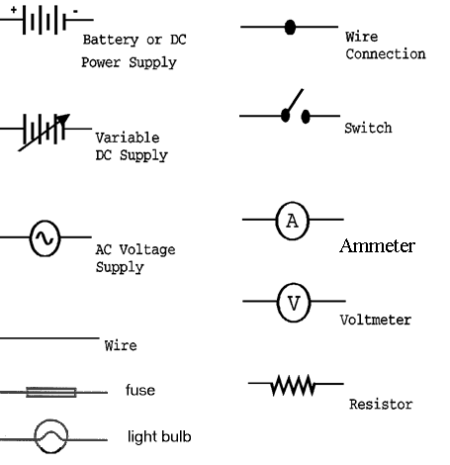**Circuit diagrams** : **[6 ]**

Use the symbols in the chart to draw the following circuits.

**Circuit 1: Series Circuit**

A series circuit consisting of a battery, a switch and two light bulbs connected in series. There is a voltmeter measuring potential difference across the battery and an ammeter measuring current going into the first bulb.

**Circuit 2: Parallel Circuit**

A parallel circuit consisting of two batteries in series connected to a switch which controls the entire circuit. The batteries are connected in parallel to two bulbs which are connected in parallel to each other. There are switches controlling the current through each bulb and an ammeter measuring current through each bulb. There is an ammeter measuring current flowing from the batteries and a voltmeter is connected to measure the total voltage across the batteries.

1. **Circuit Simulation: Go the following Circuit Simulation Website**

<http://phet.colorado.edu/en/simulation/circuit-construction-kit-ac-virtual-lab>.

**You will use this simulation to build and analyze the two circuits above. The answers for the circuit simulation may be recorded directly on this worksheet.**

**Hints on using the simulator**:

*Drag each item from the menu bar on the right to begin constructing your circuit.*

*If you make a mistake, right click on the item to delete it.*

*You can stretch the wires by pulling on the connecting “nodes” at each end.*

*Components can only be attached at the connecting nodes*. *To break the circuit and add a new component, right click on a junction point and choose “Split Junction”*

*To run the circuit click on the play/pause button (> ||)*

**Circuit 1: Build Circuit 1 without the ammeter. Close the switch and observe what happens. ]7]**

1. Describe the particle movement in the circuit when the switch closed.
2. Click on the Voltmeter tool at the far right and measure the voltage across each of the devices:

Battery voltage: ________ Bulb 1 voltage: ______ Bulb 2 voltage: ______ Switch voltage: ____

Describe any interesting relationships you notice with the voltage values:

1. Click on the ammeter tool and insert the ammeter between the two bulbs. Record the current value: Current value between bulbs: __________________

Delete this ammeter and re-insert the ammeter between the battery and the switch. Record the current value: Current value between battery and switch: __________________

Describe any interesting relationships you notice with the current values:

1. Use the battery voltage and current value to find the total resistance in the circuit using one of the formulas from page 1!

**Circuit 2: Build Circuit 2. Close the switch and observe what happens. [6]**

Record the current in each of the ammeters:

a)Current from battery: _____ Current through bulb 1: _____ Current through bulb 2: _______

Describe any interesting relationships you notice with the current values:

b)Use the voltmeter to measure the voltage across each device.

Voltage across battery: _____ Voltage across bulb 1: _____ Voltage across bulb 2: _______

Describe any interesting relationships you notice with the voltage values:

c)Remove one battery and run the simulation again. Measure the total current coming out of the

battery and the total voltage across the battery.

Voltage across one battery: ____________ Total current from battery: ___________

Calculate the total resistance of the circuit using the battery voltage and total current from the battery as you did in step (d) for Circuit 1:

**Comparing circuits**: **[4]**

1. How did the total resistance in circuit 1 compare with the total resistance in circuit 2 (when it was running with one battery)?

What does this result indicated about the total resistance when you place components in series versus placing components in parallel?

1. What conclusions can you draw about voltages and current in a series circuit?
2. What conclusions can you draw about voltage and currents in parallel circuit?

**Total : _________ [ 40 marks]** **Communication**

**Thank you for completing your Electricity ISU review assignment!**